Clifton Cameras Product Specification

Sony FE 24-240mm f3.5-6.3 OSS Lens Full Spec

Specifications
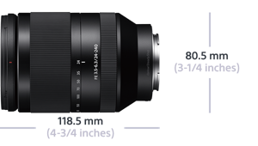
- Optics/Lens
  - Lens Mount Type : Sony E-mount
  - Lens Stabilization : Optical SteadyShot
  - Minimum Focus Distance : 1.64'-2.63' 0.5m-0.8m
  - Lens Groups-Elements : 12 groups, 17 elements
  - Filter Diameter : 72mm
  - Lens Type : 35mm full frame
  - Aperture (Max.) : f/3.5-6.3
  - Aperture (Min.) : f/22-40
  - Aperture : Circular
  - Maximum Magnification : 0.27x
  - Focal Length (35mm equivalent) : 24mm - 240mm (35mm) 36mm - 360mm (APS-C)
  - Aperture Blade : 7 blades (Circular aperture)
  - Angle of View : 61° - 6°50' (APSC) 84° - 10° (35mm)
- Weights and Measurements
  - Dimensions (Approx.) : 3-1/4" x 4-3/4" (80.5 x 118.5mm)
  - Weight (Approx.) : 27.6 oz (780g)

